Liquid Fuel Engine Test Stand

CAD Beginners Guide and Revisions

Last Updated: 5/30/2019

Authors: Matthew Ng

Contact: matther_ng@yahoo.com

**General Information** **3**

**Updates from previous version** **3**

Re-designing of the test stand 3

Swagelok fittings to AN 37o fittings 3

Material change from brass fittings 3

Igniter System Changes 4

Elimination of fittings 4

Addition of joggles to tubes 4

Updated placeholders 5

Pressure panel placement 5

Updated test stand structure 5

Updated load cell engine mounting 5

**Place Holders** **5**

- Fuel vent valve 5

**Tubing Guide** **5**

- General Guidelines 5

- Tubing Process 6

- Drawings for Manufacturing 12

- CAD Fitting resources 13

# **General Information**

All necessary Solidworks files can be found at <https://github.com/psas/liquid-engine-test-stand/tree/master/cad/SW_CAD>

Note: Most components aside from fittings were created using dimensions from calipers and are only accurate for dimensioning purposes.

# **Updates from previous version**

### **Introduction**

As with designing any product having a good idea of what components are needed and where they go are essential. While evaluating the computer generated model left by the previous capstone team it was clear that it did not accurately reflect what was planned as some components were not up to date and some were missing. As shown in Fig 13 the test stand was heavily re-designed to better represent what was going to be constructed.

### **Swagelok fittings to AN 37o fittings**

Most of the fittings for both the fuel and LOX side have been switched from swagelok to AN 37o fittings. This is because AN fittings perform well under vibration, high pressures, and cryogenic conditions. The sleeve used to back up the flared end of the tube ensures tube alignment with fitting axis, reduces mechanical strain on tube, and compensates for vibrations. The flared end has a minimal change in geometry compared to swagelok resulting in negligible pressure losses. The threads for AN fittings are coarser which provides individual threads with more strength and resists cross-threading, a common issue with the fine-threaded swagelok fittings.

### **Material change from brass fittings**

The original design called for a mixture of stainless steel, brass, and aluminum fittings. Under the redesign the stand now has three distinct sections, each with its own material selections. The pressure panel is built out of swagelok brass fittings and aluminum tube. Aluminum tube was used as brass fittings were available and seal well with aluminum. The fuel side of the stand, below the fuel tank, will consist of aluminum materials only except for valves. Currently it is a mixture of brass and aluminum. The oxidizer side is made from stainless steel. This will allow for better maintenance of the system as each section can be pulled apart for storage reducing corrosion. Stainless steel was used for the liquid oxygen transport as it works well at cryogenic temperatures and is not significantly reactive with oxygen. Eventually brass and aluminum should be eliminated from the system. Aluminum is extremely subject to attack by corrosion and brass becomes brittle as galvanic corrosion pulls zinc from the alloy.

### **Igniter System Changes**

The engine provided did not have enough supporting material around the pre-existing igniter port for one to be installed. Instead, to simplify machining and avoid the issue, an external ignition system was devised. The next iterations of the engine will rely on advances in printing technology or on post-processing to provide a tap for the igniter.

The new design of the test stand gives the option for use of an external igniter, via a spring-loaded armature. This arm is designed to be able to hold an external ignition source in the correct position, until engine ignition, at which point the arm will be “blown” away from the engine. If the 2.2kN engine is tested on the stand, this armature will provide the ignition source, and it gives engine designers of future iterations of the engine an option of using an internal or external ignition source.

### **Elimination of fittings**

The stand had been designed with fittings wherever tubing needed to change direction. Fittings give the tubing a discontinuous internal surface and create very large losses on direction changes. To reduce pressure requirements tube bending replaced most of the fittings. Bent tube has near-negligible pressure loss and are more robust with geometry changes due to high pressure or extreme temperature.

### **Addition of joggles to tubes**

Since pipes have a high coefficient of thermal expansion, cryogenic temperatures will cause the tubes to contract which can result in leaks at fittings where pre-load is lost. Adding joggles to long sections of tube relieve this by allowing the tubes extra length to straighten out instead of losing pre-load.

### **Updated placeholders**

New models have been integrated into the CAD to better represent the dimensions of the components that will be installed. These models include new LOX valves for size and flared fittings, main LOX valve for actual dimensions, and main fuel valve for actual dimensions. Most models are rough volume estimates purely for dimensioning.

### **Pressure panel placement**

The pressure panel section has been moved behind the firewall to better protect it from unscheduled engine structure integrity checks. This also allows for a modular firewall to be installed on the front of the stand without need for pressure panel mounting.

### **Updated test stand structure**

The previous CAD did not match the test stand “as built” due to warpage from welding and other imperfections in fabrication. The CAD was updated to match the physical stand. Hold-down plates and other precision components including the teflon tank cushions were designed using the updated dimensions.

### **Updated load cell engine mounting**

The thrust-plate model from a 2017 master’s thesis was imported into the design.

# **Place Holders**

## - Fuel vent valve

EH40-08 normally closed valve CAD added for general dimensioning.

# **Tubing Guide**

## - General Guidelines

Depending on what you are looking for pipes are measure by inner diameter and tubes are measured by outer diameter. Tubing dimensions were used for this version of the CAD so all references to tube diameter will refer to an outer diameter.

## - Tubing Process

1. If connecting AN 37o fitting import part 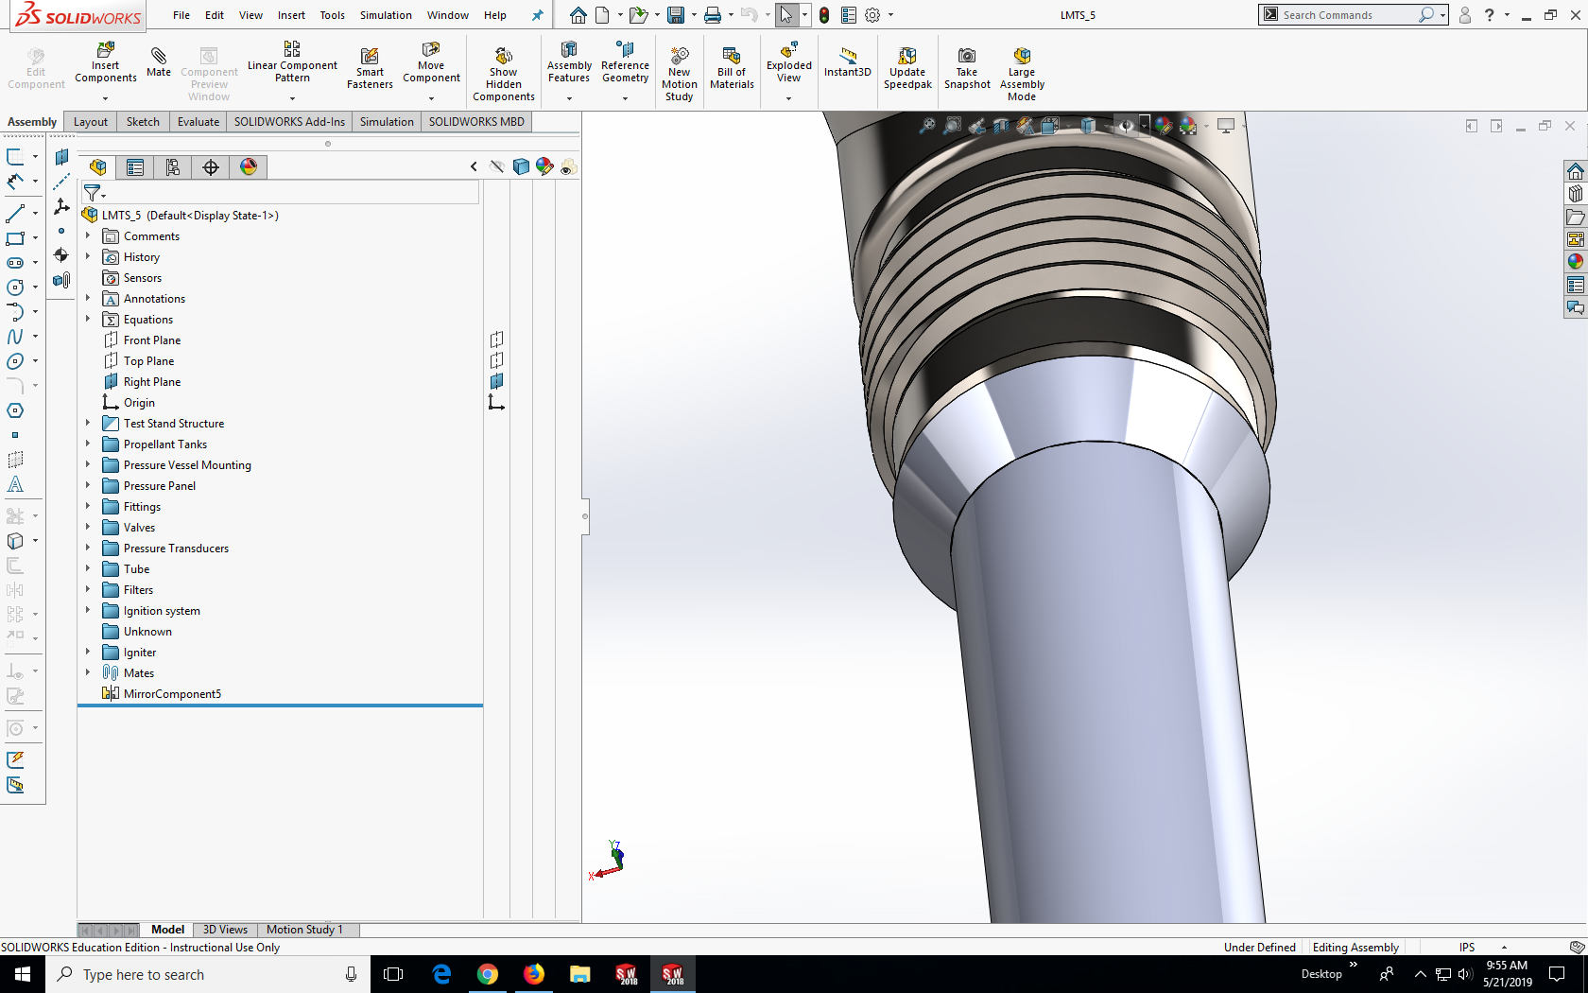 titled “Flared pipe end” with the corresponding tube diameter you are looking for. If connecting Swagelok fitting move on to step 2

2. Create a new part in the assembly 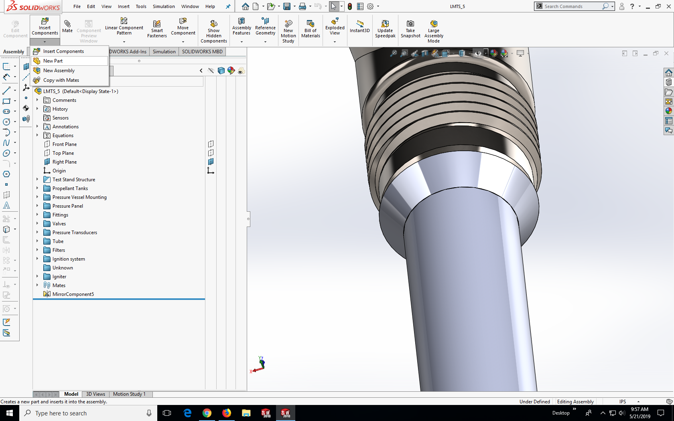 and click anywhere in the work area to confirm

3. Right click the newly created part found in your parts list and click on edit part 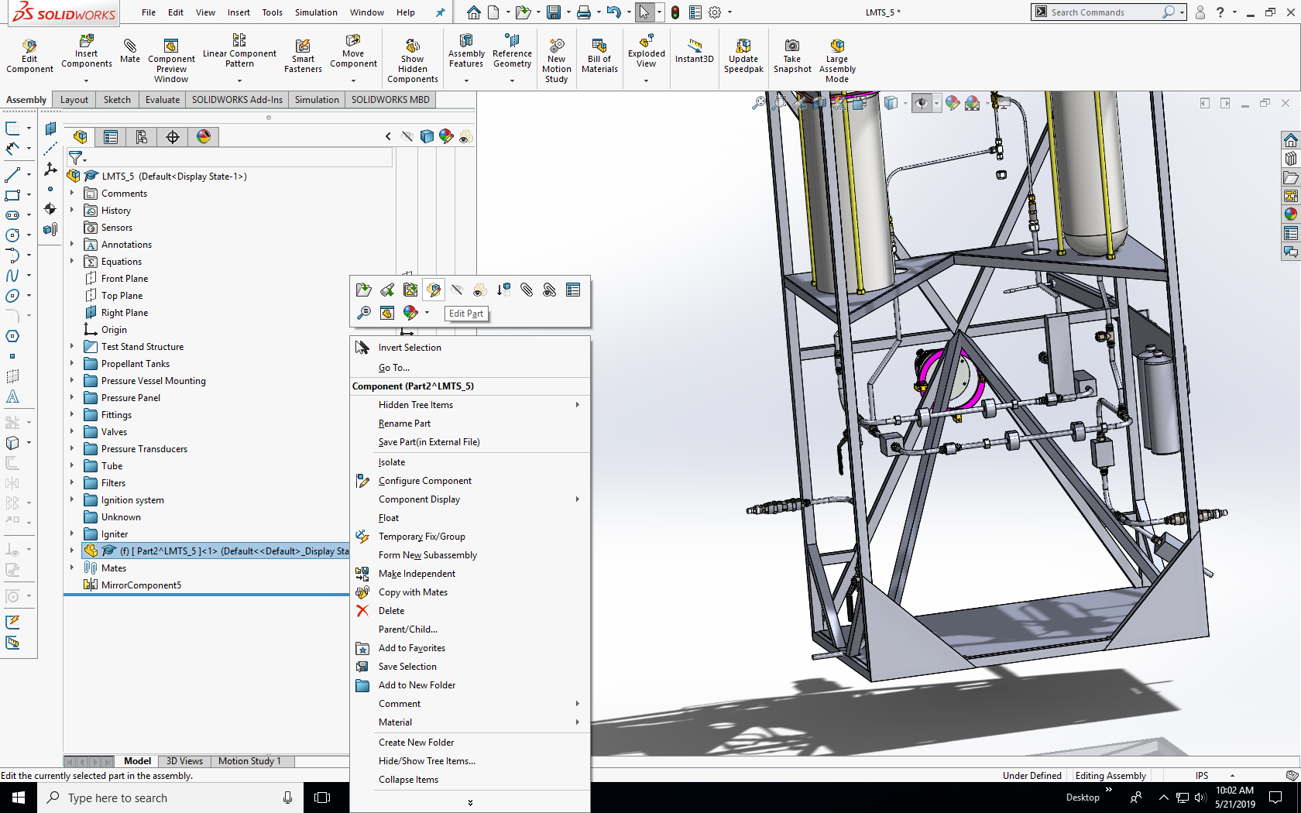

4. Go to the sketch tool and create a 3D sketch 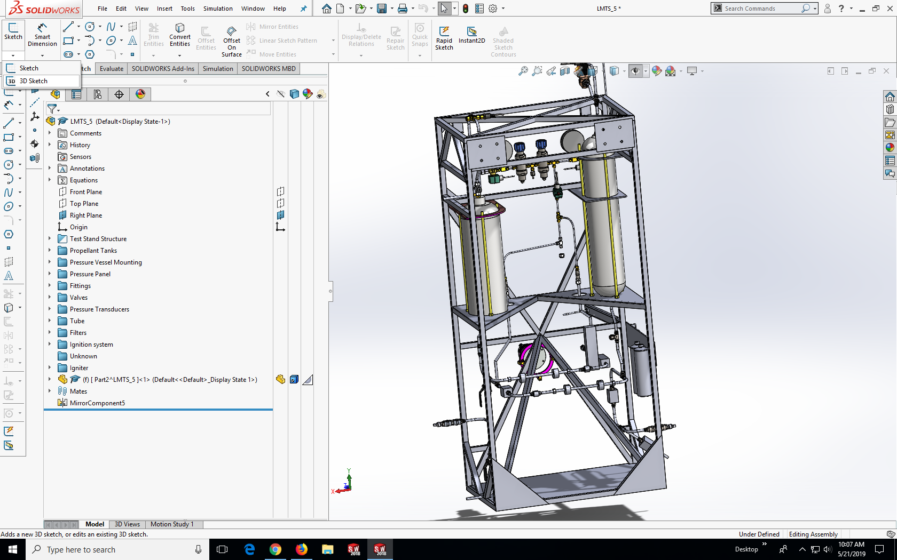

5 Using the line tool 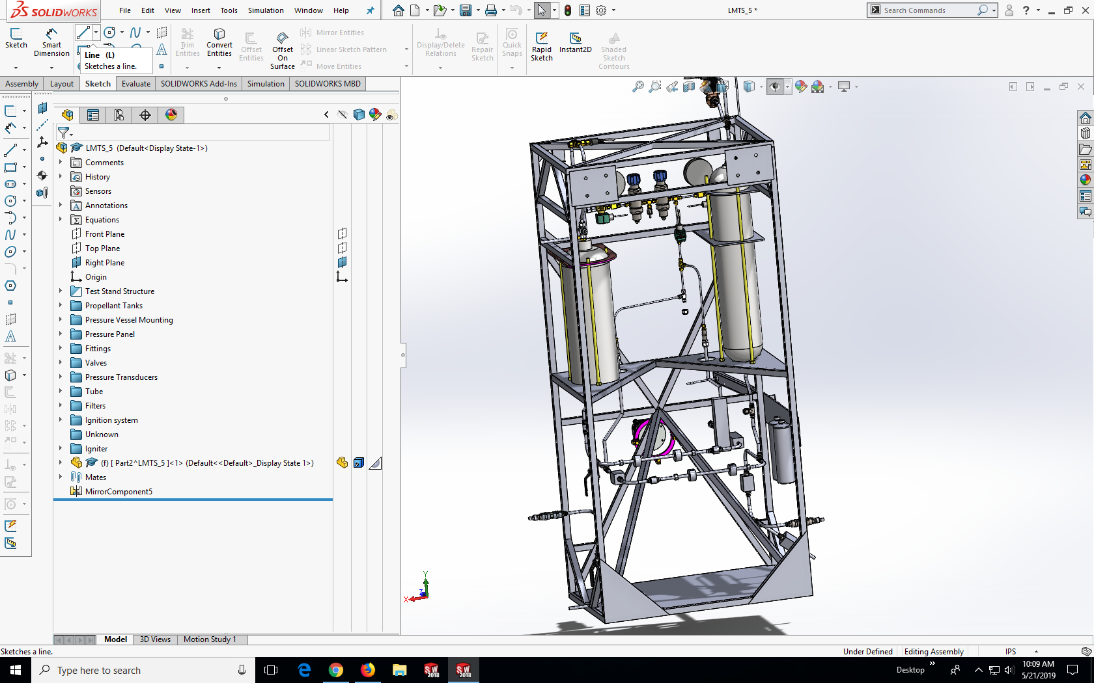sketch your path from fitting to fitting from the face of the flared pipe end

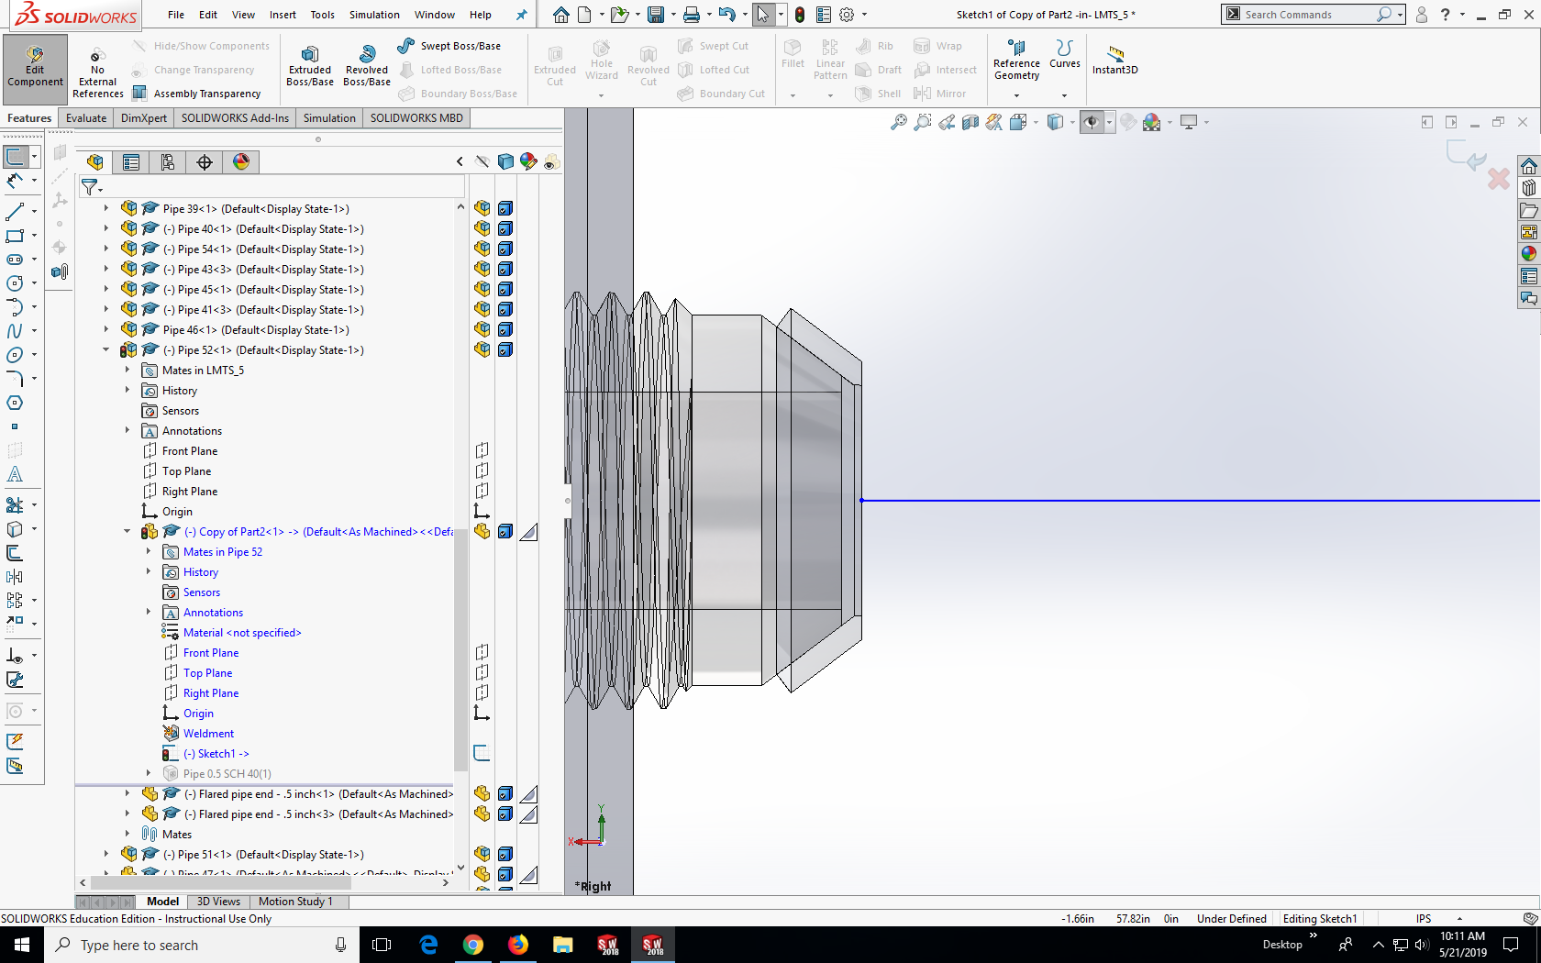

or to the back face of the Swagelok fitting.

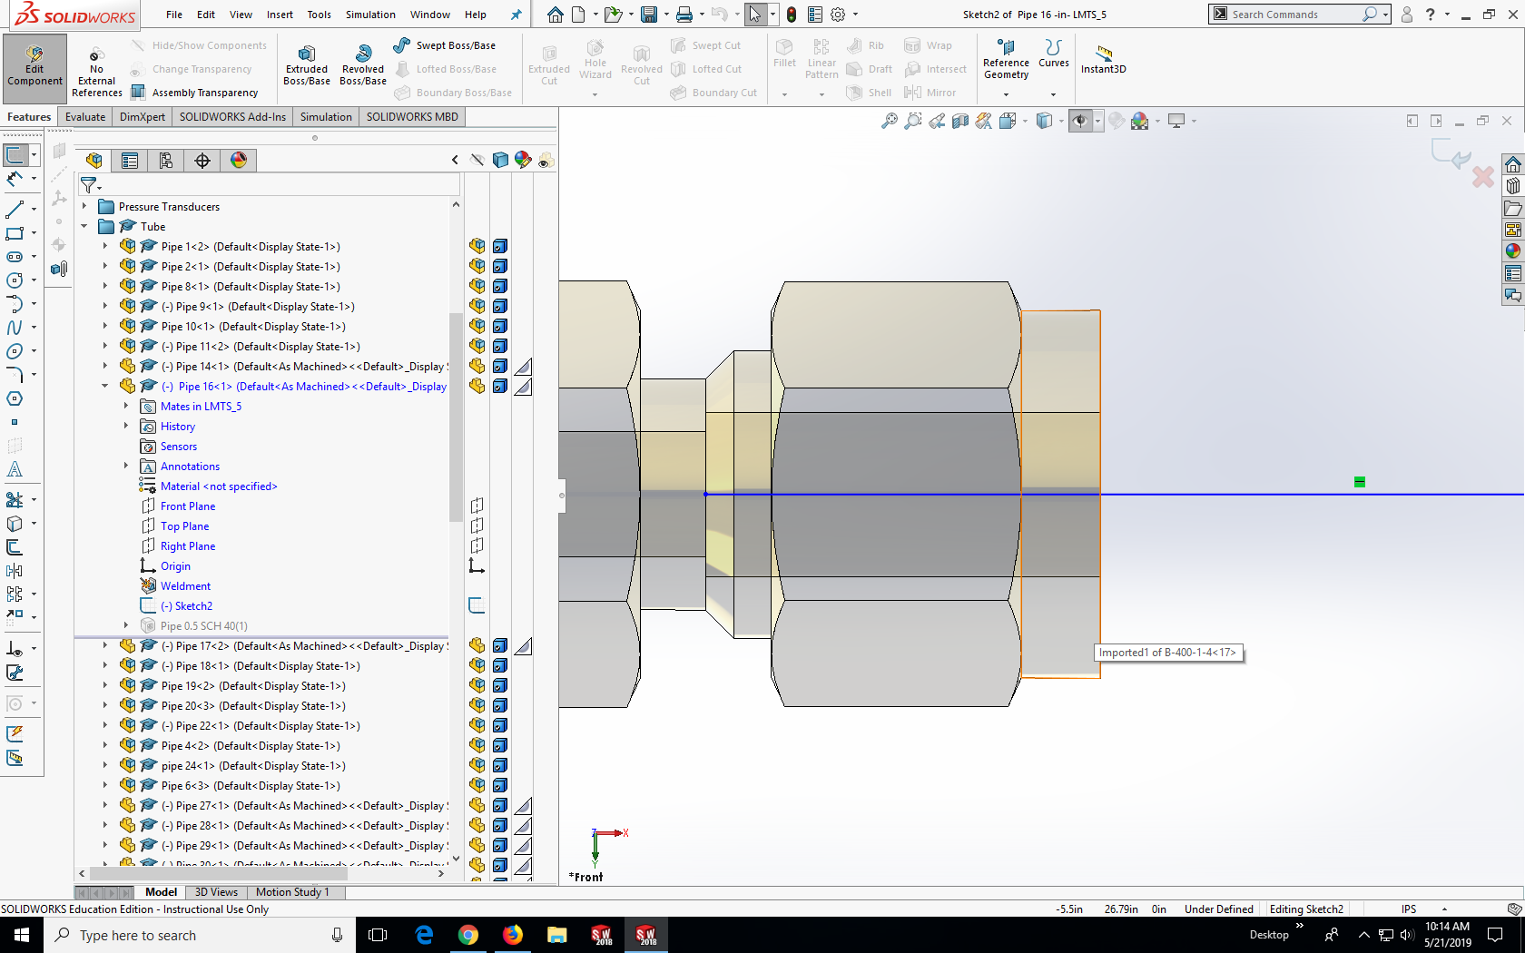

**Note:** To make room for fittings and bending during construction all initial and ending lengths of tubing must be 1.5 inch or more. Additionally to help center and make sure the faces are touching you can mate the end point of the line to the fitting using the coincident and concentric mate. This can be done by holding down ctrl and selecting the end point and any circular feature.

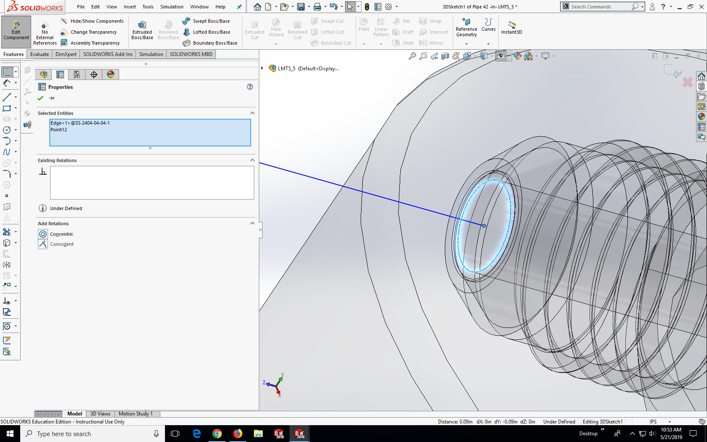

However, make sure to delete those relations after you are done as they can affect any rebuilds to the tube.

6. To add bends use the sketch fillet tool 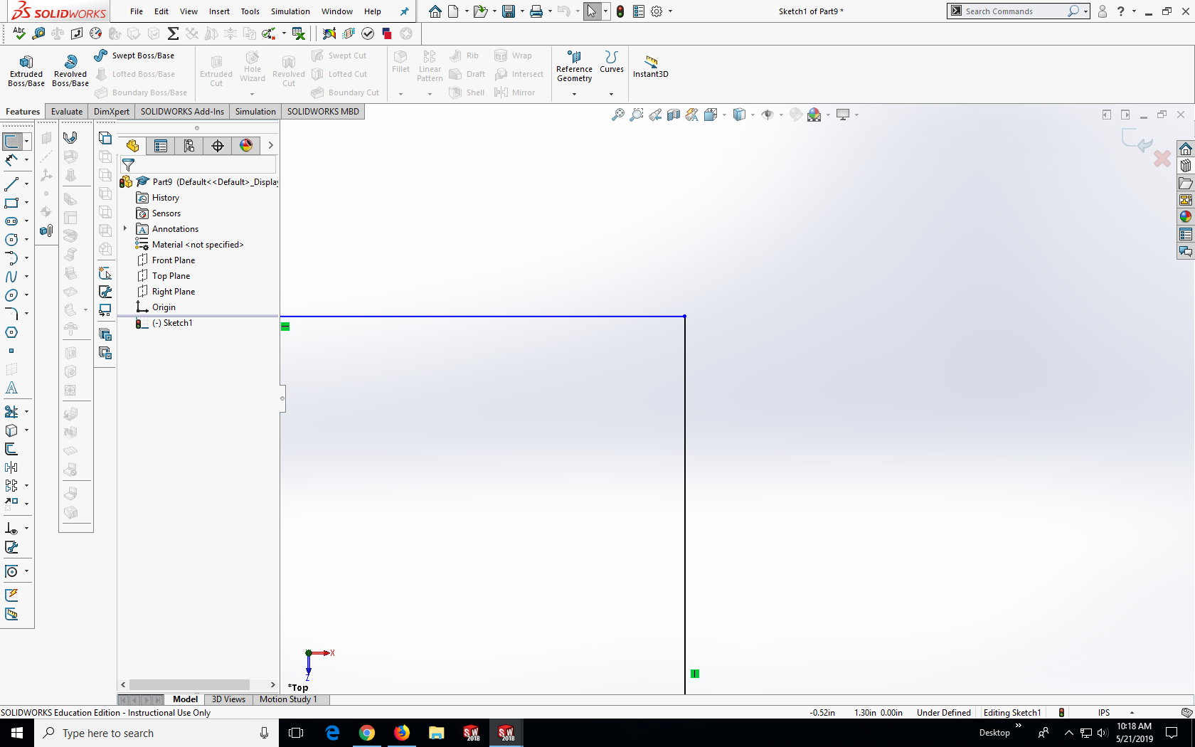 by clicking on the desired corner 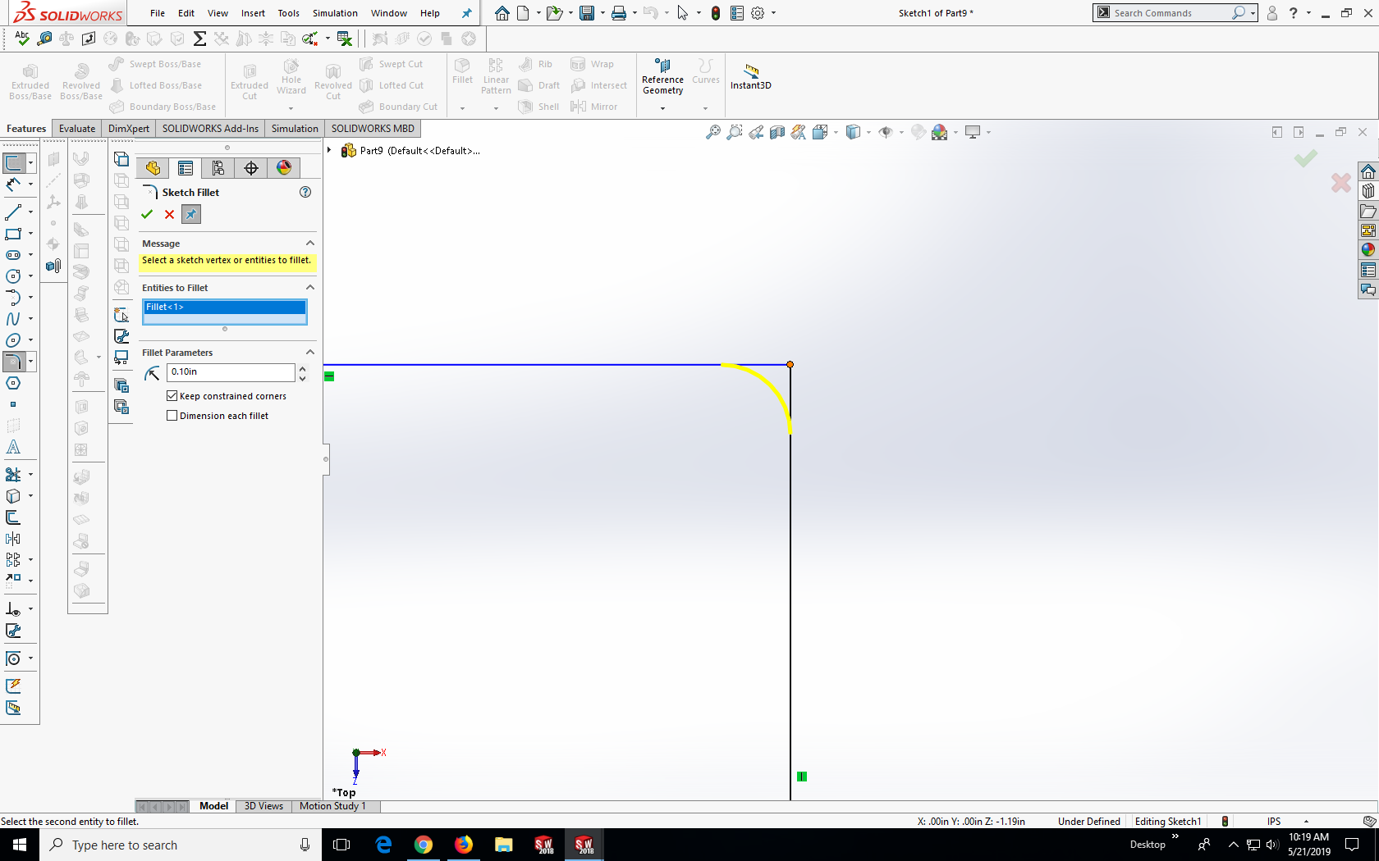

**Note:** Follow minimum bend radius according to the rocket bible found in the PSAS rocket room. In this version of the CAD .25 inch tube uses 7/8th inch bend radius and .5 inch tube uses 2 inch radius.

7. For long lengths of straight pipe include a joggle if possible

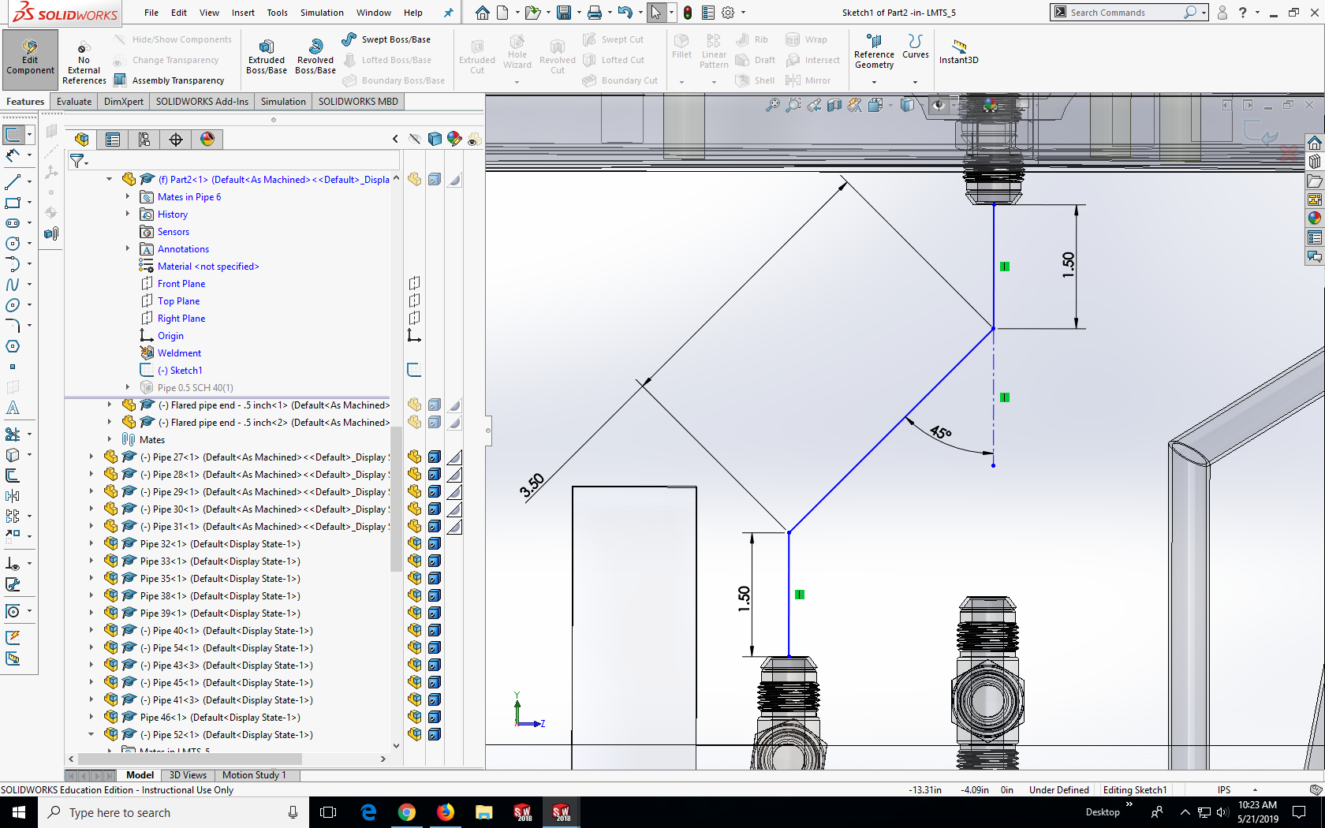

**Note:** Due to manufacturing constraints the middle length of any joggle must be 3.5 inches or more. This version of the CAD uses an 45o offset for the joggle. The angle can be adjusted for anything below 90o however it has not been tested how that affects the minimum middle length for manufacturing. All joggles in this version of the CAD use a 45o offset purely for uniformity.

8. Exit the sketch and go to insert -> weldments -> structural member

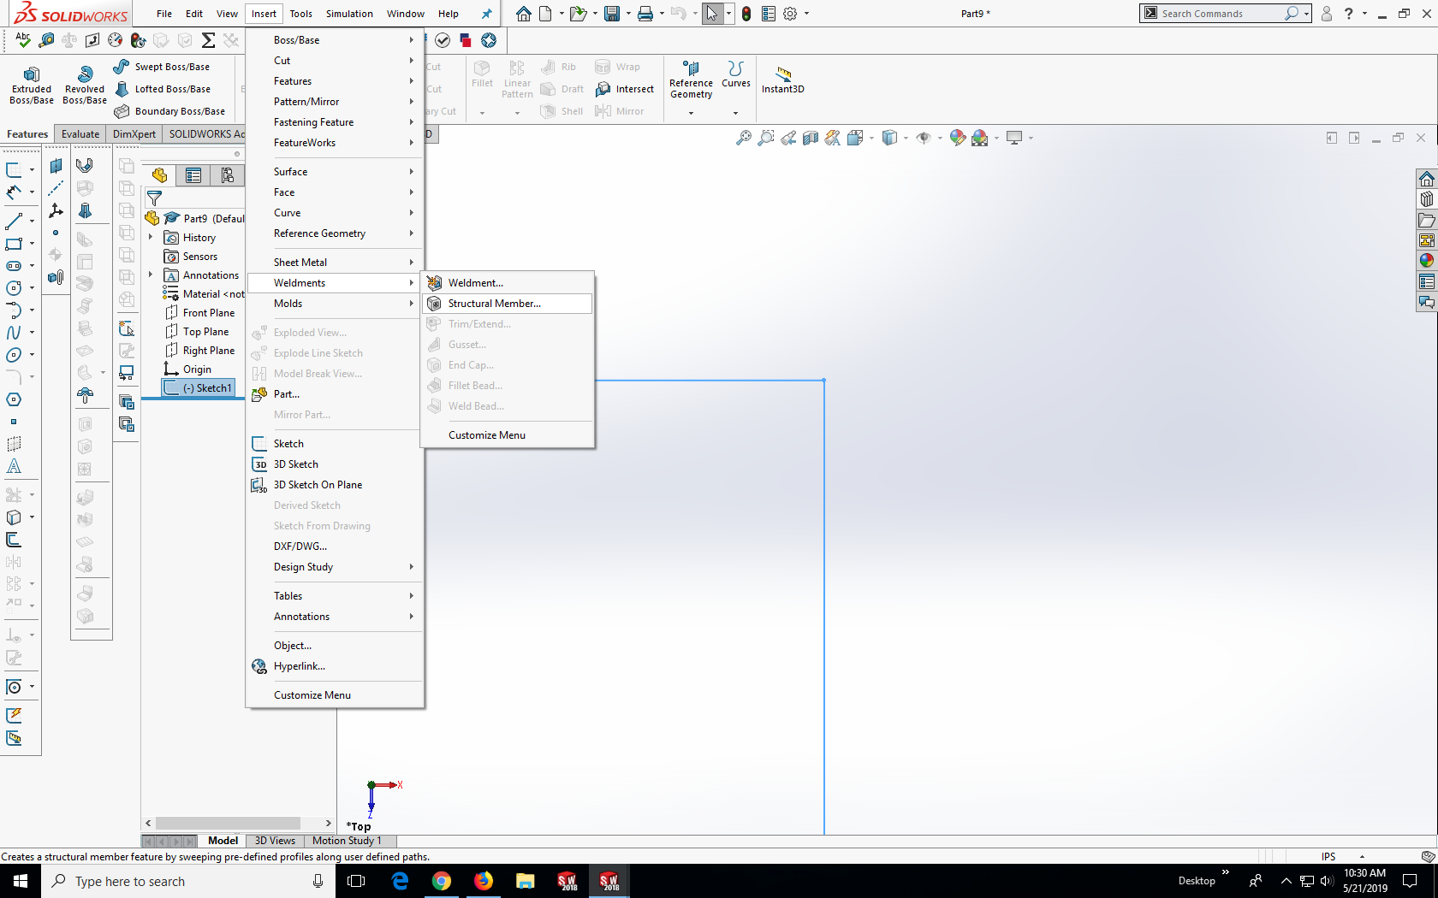

Click on the beginning section of your sketch and then the following section until you have selected all then press enter

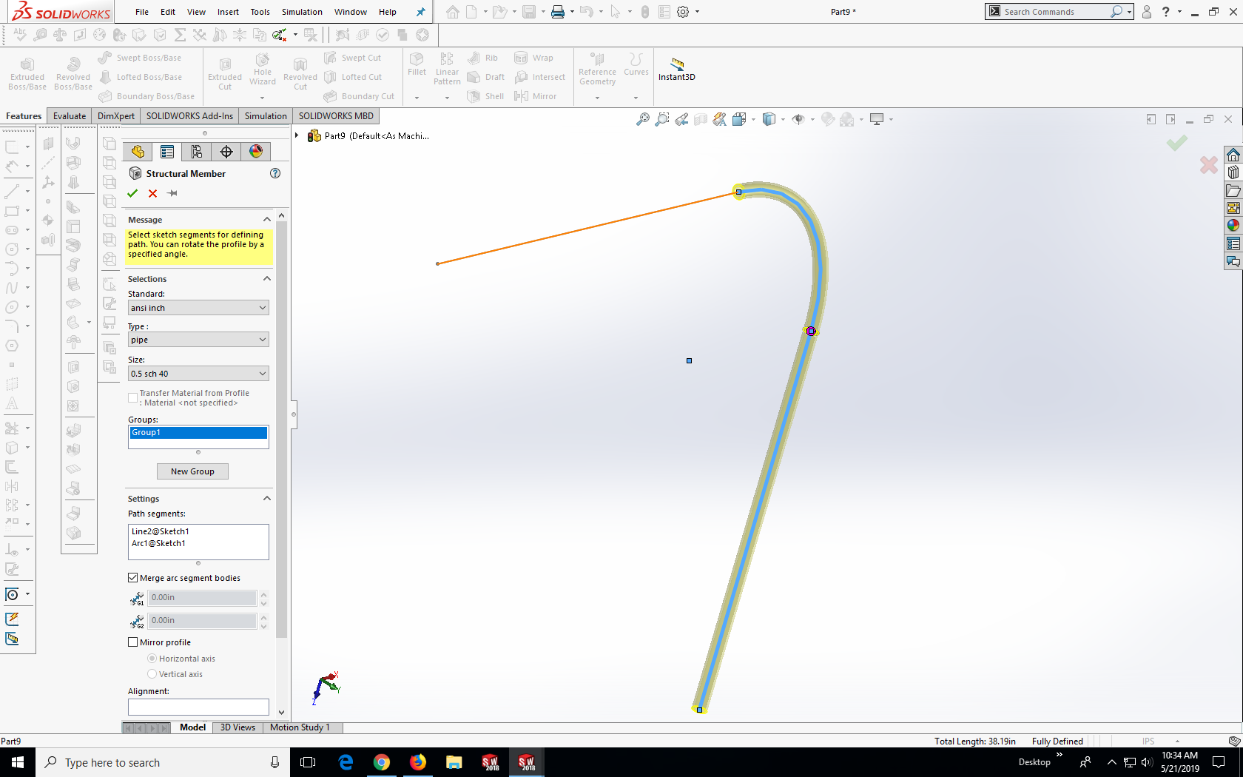

9. Left click on the pipe feature found under the part in the parts list, right click on the sketch feature then click on edit sketch.

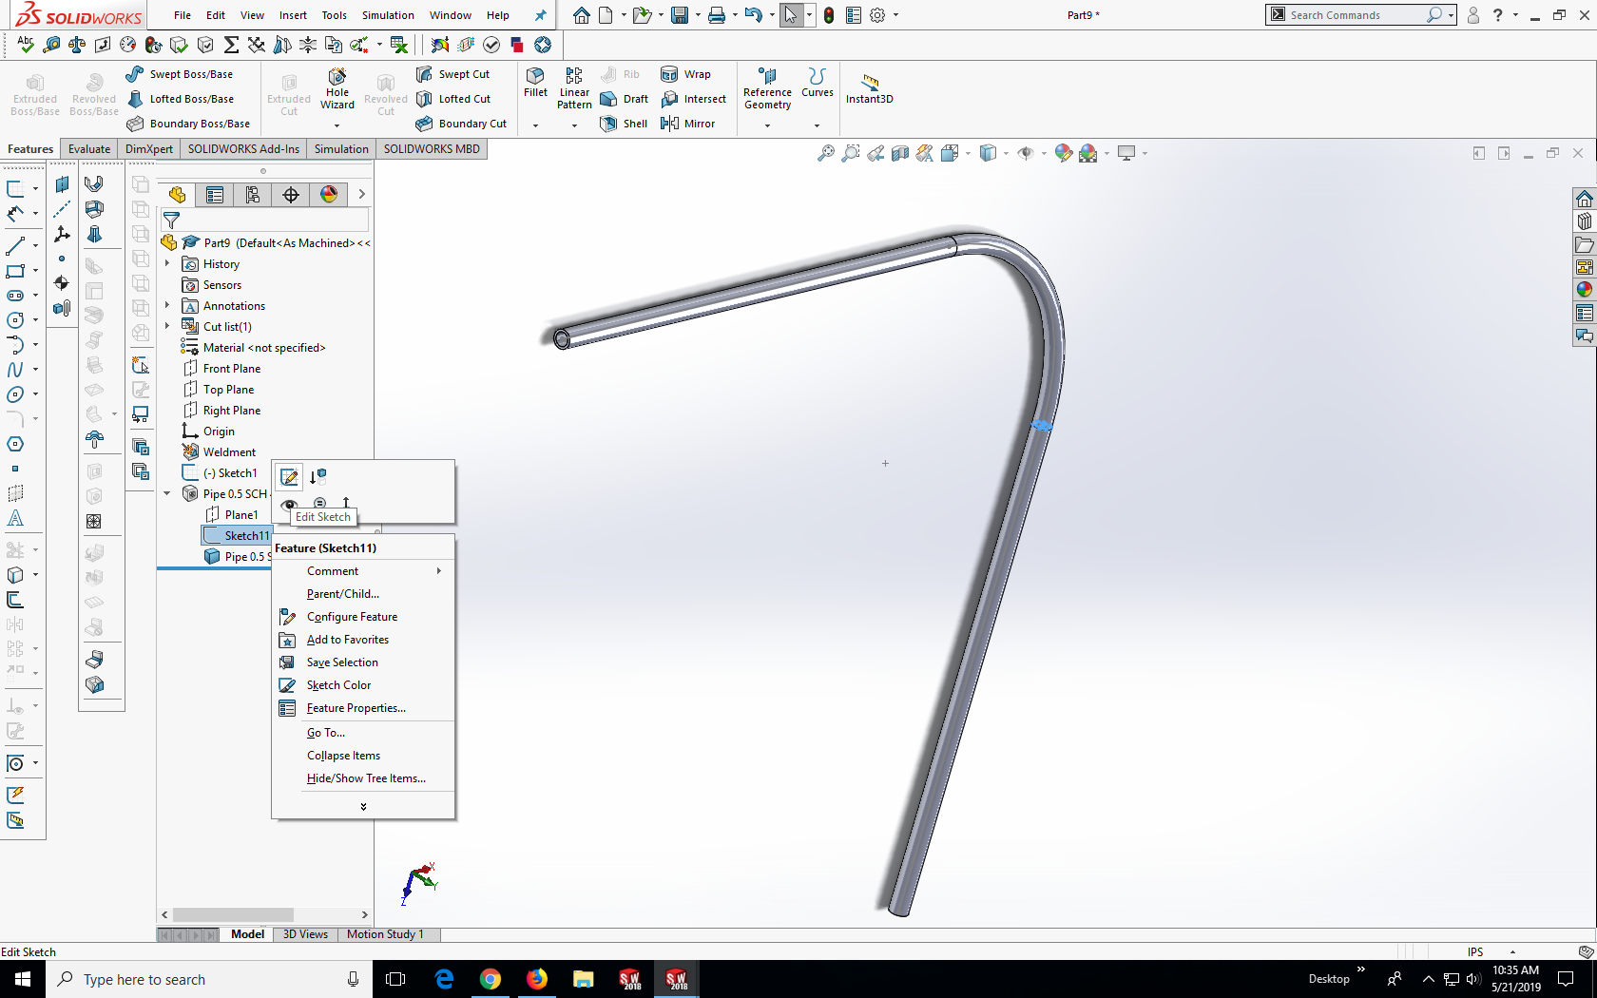

Delete the construction line leaving the outer and inner diameter. Edit the dimensions for the inner and outer diameters according to what you desire.

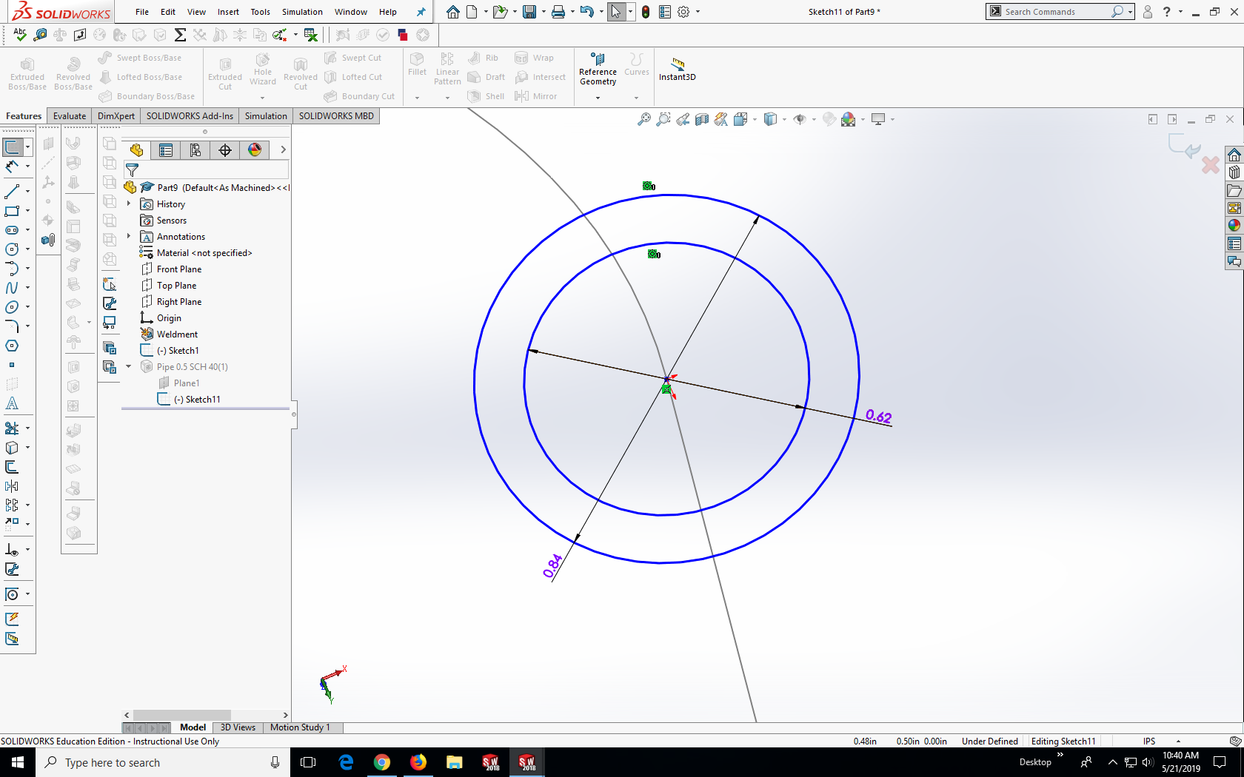

**Note:** This version of the CAD .5 inch tube has an inner diameter of .416 inches and .25 inch tube has an inner diameter of .206 inches. These values are based off the minimum wall thicknesses found in the rocket bible according to 3,000 psi (much larger psi than what will actually be operating at)

10. Right click on the part found in the parts list and click save part (in external file)

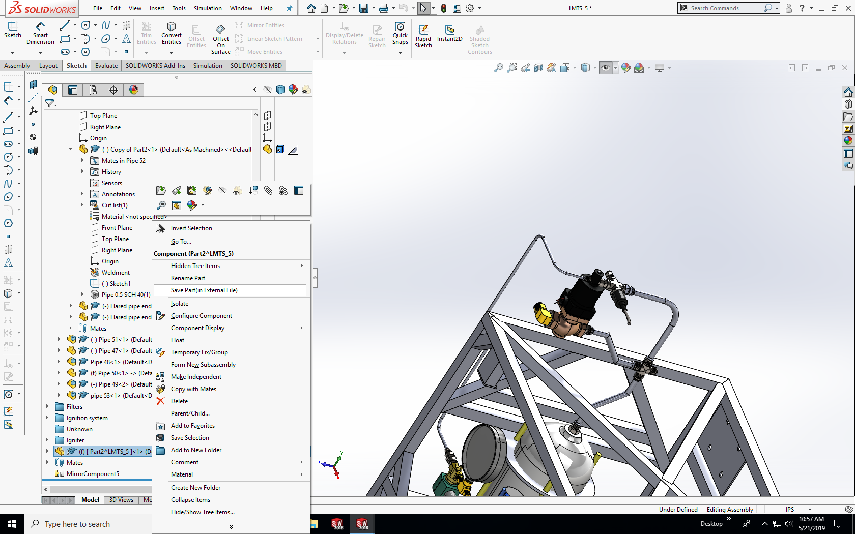

**Note:** To reuse any tube designs import another one into the assembly, right click on it and click make independent. Make sure to make the tube part independent as making assemblies independent will not make the tube part independent which can result in other tubes change when you are editing one if another assembly has the same tube part.

11. If flared pipe ends are used make a new assembly 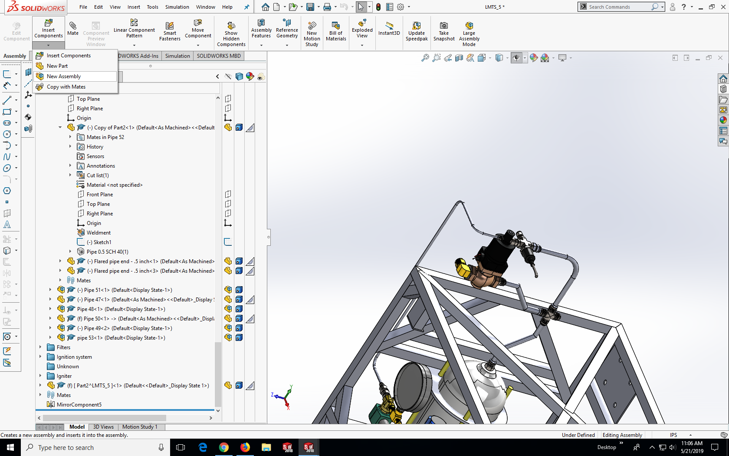 and drag the tube part and its corresponding flared pipe ends into the new assembly.

## - Drawings for Manufacturing

Tube dimensions:

Diameter

Center to center (from endpoint of one length to the beginning point of the next length)

Straight lengths (from endpoint to end of flared end if used)

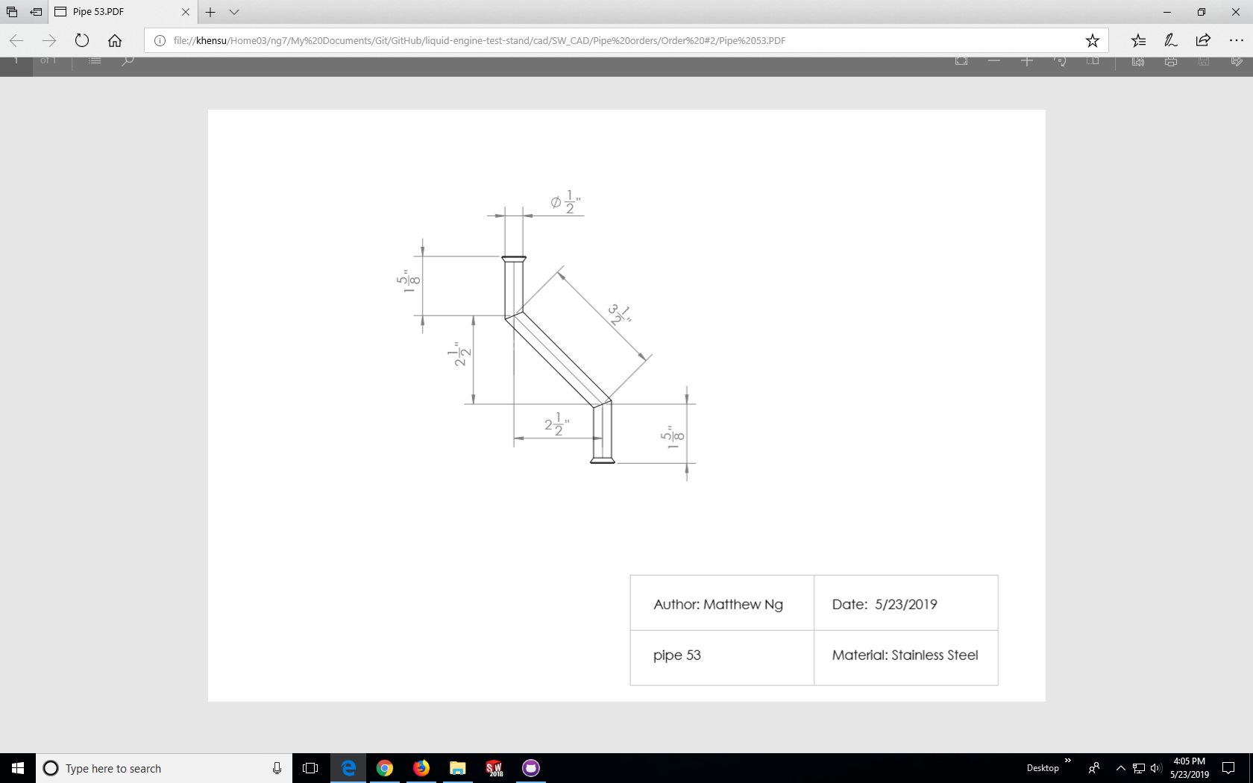

Format: In 1/8ths can be done by going to system properties 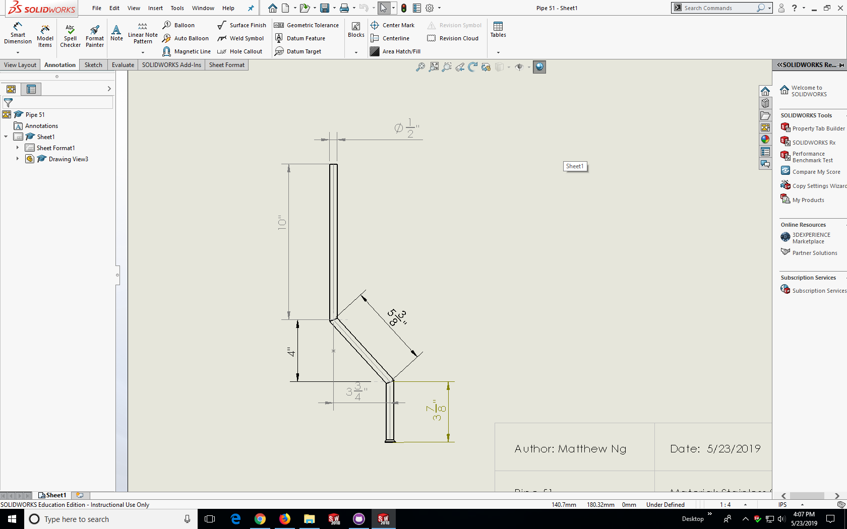 then document properties -> Units -> Fractions

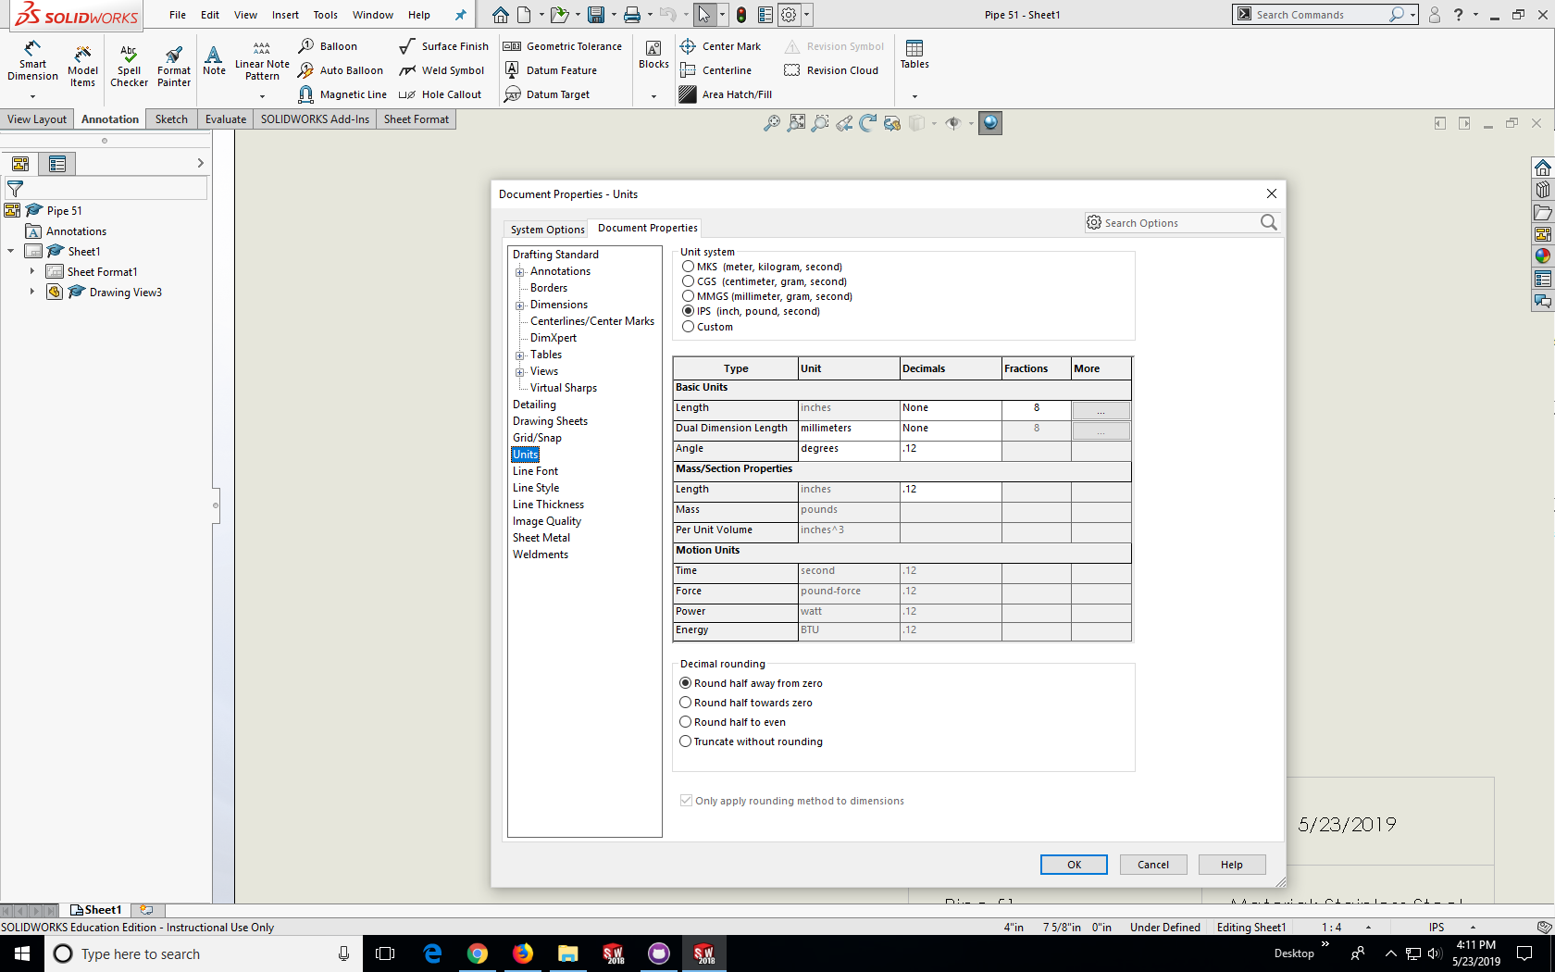

More examples can be found on Github in the CAD section under pipe orders

<https://github.com/psas/liquid-engine-test-stand/tree/master/cad/SW_CAD/Pipe%20orders>

**Note:** Convert drawings into PDFs as Solidworks drawings require the solidworks part file to open.

## - CAD Fitting resources

More information on fittings can be found in LFETS -> LFETS and LFE Technical -> Component Documentation -> Piping Hardware

<https://brennaninc.com/>

<https://www.mcmaster.com/>

<https://www.swagelok.com/en>